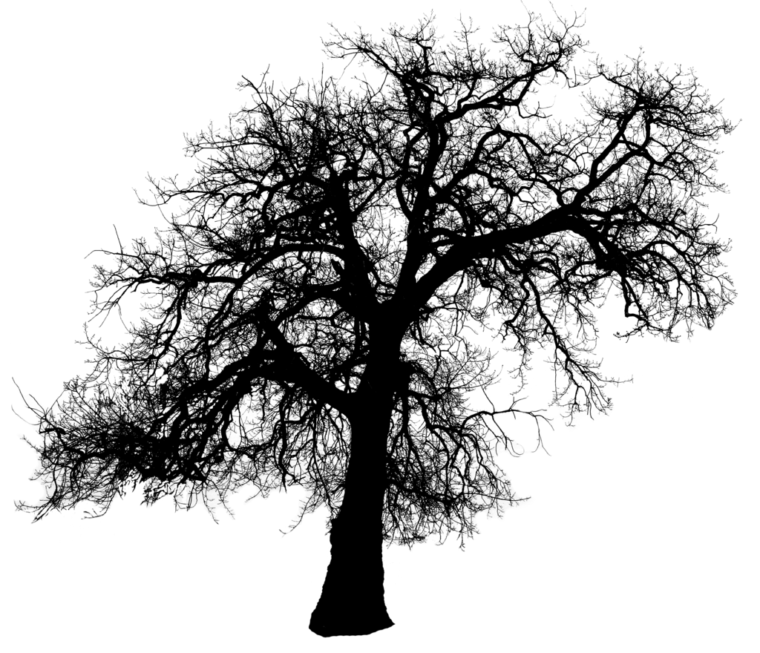

I hear the loudest, most aching sound
The dreadful noise piercing my ear drums,
My front bumper dragging across the graveled concrete
My stomach twisting
The sudden nausea
The sky was light gray
The trees darker than I’ve seen

The road was soaked and glistening in the headlights of the Jeep Cherokee in front of me. The vibrant yellow sign caught my attention in the heavy downpour. I came to a complete stop, well I thought I did. Before I could even realize, the impact. I recall the noise over and over again. The loud scrapping and screeching of her bumper against mine. Maybe I closed my eyes, or maybe I’m just blocking it out.
________________________________________________________________________

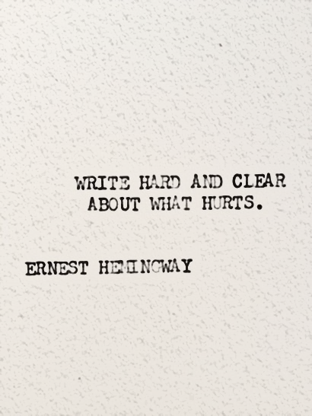

The abuse had to come to an end
At least eventually, right?
The piercing words flowing so easily
My stepfather, he was cold

A man infested with hatred
His negativity intoxicating my breathing
I knew this wasn’t forever
But to pass the time, I’d just close my eyes
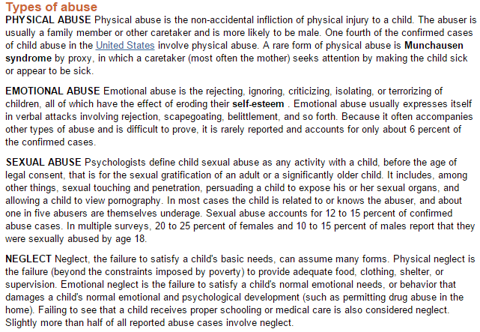
_________________________________________________________________
The accident wasn’t my fault, I didn’t hit her I swear I didn’t
That woman didn’t care she didn’t even look at me
She pulled out in front of me on purpose
She wanted me to hit her she wanted this to happen
She doesn’t care about me
She didn’t even ask me if I was okay
She doesn’t care

_____________________________________________________________________________
I did not tear my family apart,
I swear I’m not the reason why they got a divorce.
My grandfather didn’t care
He didn’t even blink,
His words flowing so effortlessly.
He was passionate,
Passionate about his hatred towards me
Passionate about me taking all of the blame.
_____________________________________________________________________________
I tried to gather my thoughts, my feelings, my terror, but tears started flowing and nothing could stop them. The woman got out of her car, she had dark hair and olive skin. I tried to walk towards her, and as I got closer she looked at me with disgust. I knew I didn’t hit her, I knew it wasn’t my fault. It doesn’t matter what she thinks, I knew what happened and everyone would believe me.
______________________________________________________________________________

I remember that Christmas like I relive it everyday
My family loved me,
I knew they believed me.
I walked through the front door,
Everyone sitting around the dinner table
Their eyes burning my flesh.
Mom said it doesn’t matter what they think,
But their eyes hurt so bad.
I thought my family loved me,
I swore they would believe me.
______________________________________________________________________________

Our vehicles colliding was no one’s fault but mine, and I knew it, I knew it the whole time.
______________________________________________________________________________

When it finally came time for them to part ways, my truth came to light. As much as my family hated the way he talked down to me, they always knew the emotional abuse he would drown me in. When the police came to my front door after confessing to my mother the entire truth, I didn’t think my family would stand against me. I couldn’t live with putting him away, and taking him from my little sister, and the way her eyes would burn my flesh knowing I’m the reason why.
My mother and step father’s divorce was not my fault
And I always knew that.
Their eyes no longer burn my flesh
It never mattered what everyone else thought
My family are the people who always loved me,
Who always believed me.
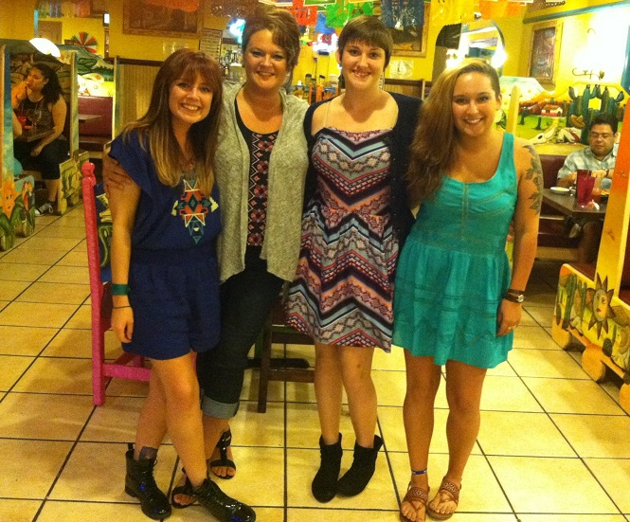
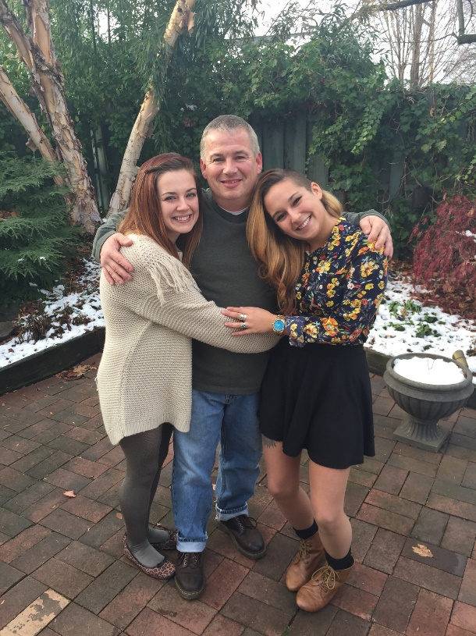

CITATION:
Baker, Howard; Wells, Ken. "Child Abuse." Gale Encyclopedia of Children's Health: Infancy through Adolescence. 2006. Encyclopedia.com. 29 Apr. 2015 <http://www.encyclopedia.com>.

